Analysis of How Volusia County Pre-k Teachers
Currently Collect Data on Their Students
Victoria Wilkerson
Webster University
October 3, 2020

The purpose of this document is to examine the need to unify data collection among Pre-k teachers. The system would offer a single, efficient mechanism facilitating the collection,
analysis, and storing of student data allowing teachers to focus more on instruction and less on data collection. According to the journal article Application of Total Quality Management in Education, “in education the focus should be on the improvement of teaching learning processes” (2007) teachers not spending all their time taking data and waiting for it to be analyzed. Data in education is used to drive instruction. How is that possible if they data has no be analyzed because it is sitting in some notebook or other data base the teacher does not have access to and has to wait for the administrator over the data to get the data back to them.
Volusia's public-school system is comprised of 84 schools, more than 62,000 students, and approximately 7,623 staff. There are 45 elementary schools, 12 middle schools, 9 high schools, 2 combination schools (K-8 and 6-12), 9 alternative or special centers, 7 charter schools and one district virtual instructional program. Approximately 1% of the employees in Volusia County Schools are Prekindergarten teachers assigned to a variety of classroom settings, such as:
- Voluntary Pre-Kindergarten (VPK) classroom comprising of typically developing 3, 4, and 5 years old students.
- Blended classroom which can be blended with Headstart, VPK, or students of employees with a percentage of the students typically developing and a percent of the students with various disabilities.
- Partial Day classes offering two sessions 7:50-11:00 AM and 11:00-2:05 PM, which are offered to parents with students with disabilities that are not accustomed to attending school or may have recently turned three years old with a mild delay in development. The student attends half a day and then goes home.
- Mild VE (various exceptionalities) classes are for students with mild developmental delays (cognitive, social, emotional and/or physical).
- Multi VE (various exceptionalities) classrooms are for students with significant developmental delays (cognitive, social, emotional and/or physical).

Although each classroom may vary in the number of students, the average enrollment may have as many as 12 students. Volusia County pre-k teachers are required to collect data on each student. There are some forms of data required including IEP goals and objectives, personal/social checklist, communication checklist, and adaptive checklist. In addition, there are other forms of data collected to provide teachers with insight into the student’s academic progress. An Individualized Educational Plan (IEP) Goals and Objectives are individualized educational goals and objectives specific to the student. The goals are centered on the students’ area of need and include curriculum, social, independent functioning, and communication. The personal/social checklist monitors how the students relate to peers and adults, play skills, emotions, and self-awareness. Communication checklist has both receptive and expressive skills. An example of receptive skills would be following directions and how they understand language. An example of expressive is how they use their language, vocabulary, and how they answer questions. Adaptive checklist looks at the students’ self-help skills, such as feeding self, independence, hygiene skills, etc. Pre-academic skills may include the following: letter recognition, letter sounds, colors, shapes, number recognition, matching skills, sorting skills, counting skills, etc. The majority of all the pre-academic skills data being collected is done with teacher created data sheets taking many various forms and is housed in whatever manner the teacher prefers. It is assumed this method is only effective as long as the same teacher remains in the class setting.
Currently, the pre-k teachers in Volusia County have multiple information systems for this data being collected and housed. For example, the teachers are allowed to create their own initial method of data collection. An example of this could be a teacher using Microsoft Word or Excel to create a data sheet. This may be unique to the teacher or they may share the data shares among their peers. If the teacher wants to use it they can, if not they can create something that works for them. Basically whatever works for them is how the data is collected.
Once the initial data is collected it may be stored in a student folder, file, or notebook which are kept for up to three years. Some of the data is transferred to an electronic data system called Eduphoria, an electronic web-based information system, used to collect only the Personal/Social, Communication, and Adaptive checklists. Although Eduphoria does give teachers access to reports, the teachers do not have access to data analysis. The teacher has to wait up to two weeks to get the data analyzed by county personal and then sent back to the teacher to use for instructional decisions. Eduphoria also only allows data to be entered into the system three times a year and there is only a one week window where the data can be entered. Teachers can only do a comparison of progress on the students two times a year; the middle and the end. The data put in the beginning of the year is the baseline data.
Another data collection system being used by some of the Volusia County pre-k teachers is called Rethink which is a web-based program that allows the teacher to collect data on their students’ IEP goals and objectives, as well as behavior. It provides data analysis for the teachers to help drive their instruction. It provides the teacher with instructional materials to help teach a skill or reteach a skill the student may be struggling with. However, the IEP goals and objectives the system offers to the teachers do not align with the IEP goals and objectives Volusia County uses. The teacher has to search their goal bank, find one that is similar to what the goal is for the student, and then modify it to align with what the students Individual Educational Plan is before they can use the system. The IEP is a Federal document and must be adhered to as it is written. Only a few teachers in the county utilize this system to track their IEP goals.
Conclusion, the current system of data collection and analysis is inefficient with the teachers’ data on their students spread across multiple student information systems. Data collection via old school paper and pencil, to electronic systems some systems, some of which are required while others are optional. Teachers are required to use multiple log-in credentials depending on the system being used. They are collecting data and then transferring data to another system for analysis or storage. There is no consistency in how the data is being collected, stored, or analyzed from teacher to teacher. The current methods being used are taking away from instructional time and burdensome to teachers. Based on the reading from Deming’s Out of the Crisis, “improve constantly and forever the system of production and service better allocation the human effort” (2000). Based on an article by Sawah, it is possible to build web-based platform with “the goal of collecting, storing, and sharing data within a larger network of data providers and end users” (2013). When reading the article Applying the Principles of Total Quality Management (TQM), we must “analyze the process to determine what changes can be made to make it better” (1998).
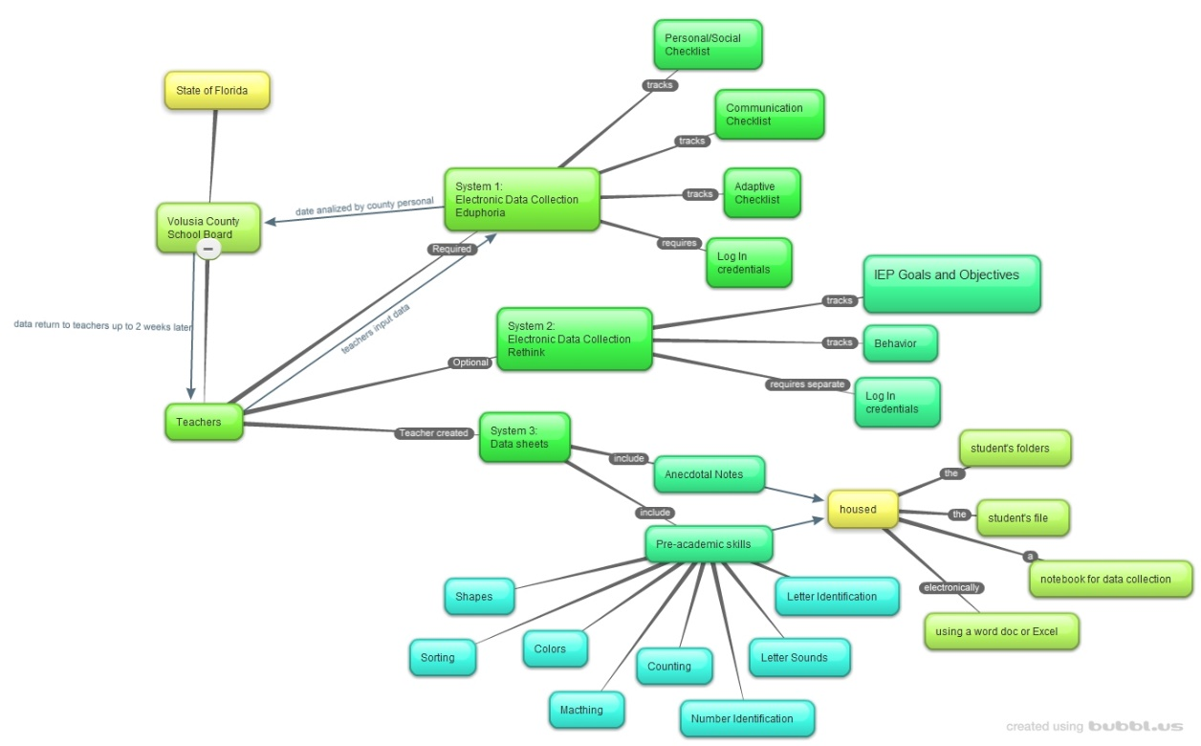
**For a larger view of graph see Appendix A
Deming, W. E. (n.d.). (2000). Out of the crisis. Cambridge: M I T Press
Farooq, M. S.; Akhtar, M. S.; Ullah, S. Zia; Memon, R. A. (2007). Application of Total Quality Management in Education. Journal of Quality and Technology Management v3 n2, 87-97
Iwanaga, T., Sawah, S. E., & Jakeman, A. (2013). Design and implementation of a web-based groundwater data management system. Mathematics and Computers in Simulation, 93, 164-174. doi:10.1016/j.matcom.2012.11.009
Volusia County Schools. Retrieved from https://www.vcsedu.org/community-information-services/demographics-statistics on October 3, 2020.
Winn, R. C., & Green, R. S. (1998). Applying Total Quality Management to the Educational Process*. Engaging Ed, 14(1), 24-29. Retrieved September 2, 2020, from file:///Users/natalieflora/Downloads/winn1998_applying_total_quality_management_to_the_educational_proces.pdf

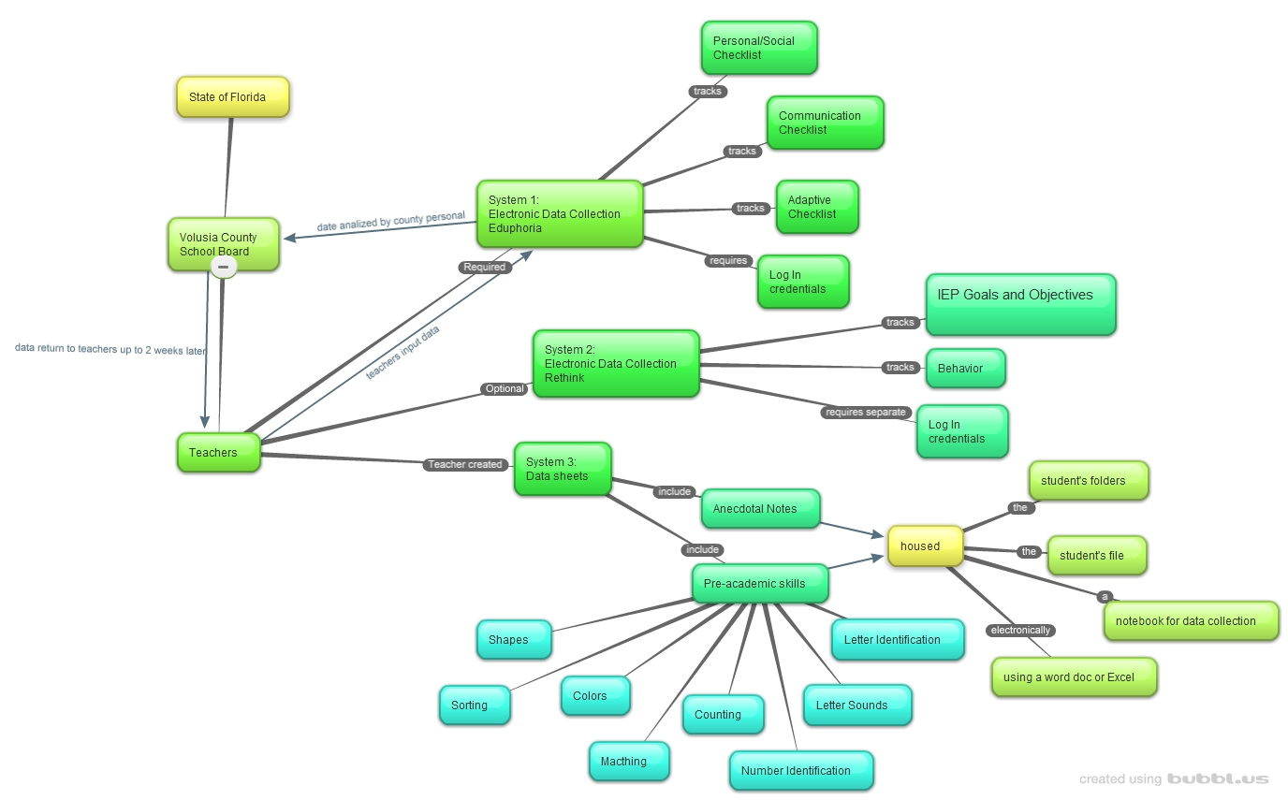
Appendix A

